Time series Notes

**Lecture 1**

1. quntmod (R access for Yahoo Finance to get data)

2. Assume time are equally spaced, denote increment by h

3. Data interpretation: talk to your manager, regulator…

4. ergodic is good for finance, but not happened right now (never happened now)

5. Weak-stationary (covariance-stationary)

6. Typo formula(9): E(X­t)=at+b

**AR(p)**

1. Python stats package (statsmodels)

2. typo formula (15): square root of 

**MLE**

1. (negative) Log likelihood: (negative find minimum) find maximum

2. 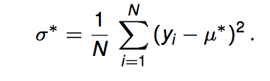 Typo: should be sigma^2

**MLE for AR(1)**

1. conditional MLE method

**AR(2)**

1. R0=1

2. z is complex number in operator 

All Phis are constant

**Lag operators and characteristic roots**

*Sufficient condition: a time series model given by the lag form equation* (44) *is covariance stationary if the roots of the polynomial* ψ(*z*) *lie outside of the unit circle.*

(**MARK**: compare with unit root test next lecture)

**AR(p)**

1. AIC: lowest is preferred; BIC: lowest is preferred

**MA(1)**

1. Always covariance-stationary

2. Typo: last term should be (x-mu)

**ARMA(p,q)**

1. Typo: no subscript t in the expectation

2. The actual value of AR(1) at time t+1 is

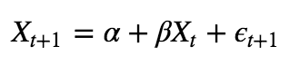Therefore



3. Typo:

should be \spsilon_{t+2}

4. Forecasting variance will converge as k goes to infinity

**Lecture 2**

1.P3  weak converge condition

2.